

Amazon Recommendation System

# Content:

1.Introduction

2. Existing System

3. Proposed System

4. Software Requirements

5. Hardware Requirements

6. Architectural diagram

7. Dataflow diagramTable Design

8.Data Dictionary

9. Relational diagram

10. Program design

11.Testing

12. Conclusion

13. References

14.screenshot

# Introduction:

Amazon's recommendation system is a complex and sophisticated algorithm that uses a variety of factors to suggest products to users. These factors include.

* User history: The system takes into account the products that a user has previously purchased, viewed, or rated.
* Item metadata: The system also considers the metadata of the products themselves, such as their category, price, and popularity.
* User demographics: The system may also take into account the user's demographics, such as their age, gender, and location.

The Amazon recommendation system is constantly being updated and improved. In recent years, Amazon has begun to use machine learning techniques to make its recommendations even more personalized.

The Amazon recommendation system is a critical part of the Amazon website. It helps to increase user engagement and sales. According to a study by McKinsey, 35% of Amazon web sales were generated through recommended items.

Here are some of the benefits of Amazon's recommendation system:

* Personalized recommendations: The system takes into account the user's past history and interests to make recommendations that are more likely to be relevant.
* Increased engagement: The system can help to keep users engaged on the Amazon website by providing them with new and interesting products to explore.
* Increased sales: The system can help to increase sales by suggesting products that users are likely to be interested in.

The Amazon recommendation system is a valuable tool for both users and Amazon. It helps users to find the products that they are interested in, and it helps Amazon to increase sales.

# Existing System:

* Item-based collaborative filtering: This is the main algorithm used by Amazon's recommendation system. It works by finding items that are similar to items that a user has previously purchased or rated. This is done by calculating the similarity between items based on their attributes, such as product categories, product ratings, and customer reviews.
* Content-based filtering: This algorithm recommends items to users based on the content of the items themselves. For example, if a user has purchased a book about cooking, the content-based filtering algorithm might recommend other books about cooking, or even kitchen appliances.
* Hybrid recommendation systems: These systems combine item-based collaborative filtering and content-based filtering to provide more personalized recommendations. For example, a hybrid recommendation system might recommend items that are similar to items that a user has previously purchased, but it might also recommend items that are based on the user's interests, as determined by their browsing history and product reviews.

# Proposed System:

The Amazon Recommendation System project will use a combination of collaborative filtering and content-based filtering to recommend products to users. Collaborative filtering will use user-item and item-item matrices to find products that are similar to those that a user has purchased or rated in the past. Content-based filtering will use product features to find products that are similar to those that a user has viewed or searched for in the past.

The system will be implemented using Amazon Personalize, which is a managed machine learning service that makes it easy to build and deploy personalized recommendations. Amazon Personalize will provide the infrastructure and algorithms needed to train and deploy the recommendation models.

The system architecture will consist of the following components:

* Data ingestion: The data ingestion component will be responsible for collecting user purchase history, product ratings, and product features. The data will be stored in a data lake.
* Model training: The model training component will be responsible for training the collaborative filtering and content-based filtering models. The models will be trained on the data in the data lake.
* Model deployment: The model deployment component will be responsible for deploying the trained models to Amazon Personalize. The models will be deployed in a production environment so that they can be used to generate recommendations for users.
* Recommendation generation: The recommendation generation component will be responsible for generating recommendations for users. The recommendations will be generated using the deployed models.

# Software Requirements:

* Data: The system will need to be able to access and process large amounts of data about users, products, and their interactions. This data can be stored in a variety of formats, such as CSV files, JSON documents, or relational databases.
* Algorithms: The system will need to use machine learning algorithms to learn from the data and generate recommendations. These algorithms can be collaborative filtering algorithms, content-based filtering algorithms, or a combination of both.
* User Interface: The system will need to have a user interface that allows users to view and interact with the recommendations. This interface can be a web-based application, a mobile app, or a voice-activated assistant.
* Performance: The system will need to be able to generate recommendations in real time, so it must be able to handle a high volume of requests.
* Scalability: The system will need to be able to scale to handle a large number of users and products.
* Security: The system will need to protect the privacy of user data.
* Jupyter note book.

# Hardware Requirements:

* Laptop: Dell latitude
* CPU: Intel core i5
* Storage: 512GB SSD
* RAM: 8GB

Architectural diagram

# 

Dataflow diagram

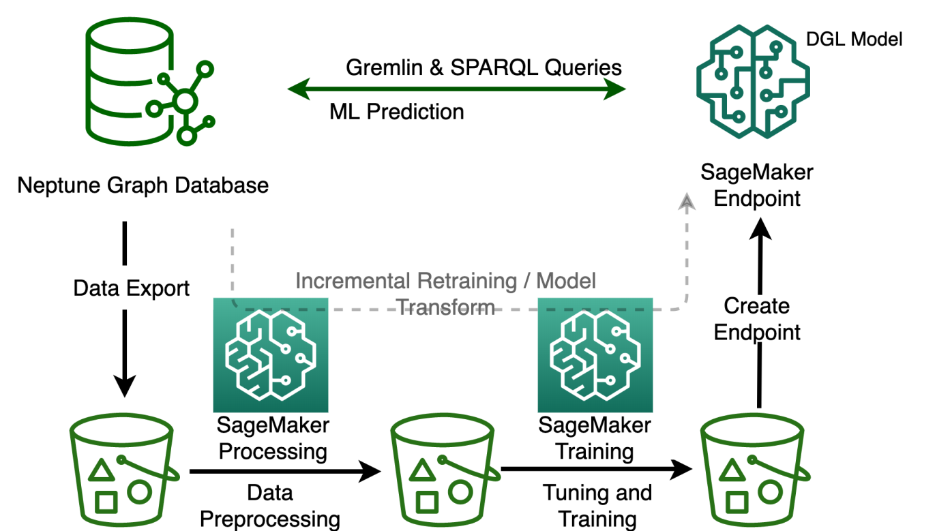

# Table Design:

|  |  |  |
| --- | --- | --- |
| Column Name | Data Type | Description |
| user_id | int | Unique identifier for a user |
| item_id | int | Unique identifier for an item |
| rating | int | Rating given by the user to the item (1-5) |
| timestamp | datetime | Date and time of the rating |

# Data Dictionary:

* Asin: The Amazon Standard Identification Number (ASIN) of the product.
* Title: The title of the product.
* price: The price of the product.
* ImUrl: The URL of the product image.
* Related: A list of products that are related to the product, such as "also bought," "also viewed," or "bought together."
* SalesRank: The sales rank of the product.
* Brand: The brand name of the product.
* Categories: A list of categories that the product belongs to.
* ReviewerID: The ID of the reviewer who wrote the review.
* ReviewerName: The name of the reviewer who wrote the review.
* Helpful: The helpfulness rating of the review.
* ReviewText: The text of the review.
* Overall: The rating of the product.
* Summary: The summary of the review.
* UnixReviewTime: The time of the review (unix time).
* ReviewTime: The time of the review (raw).

Relational diagram

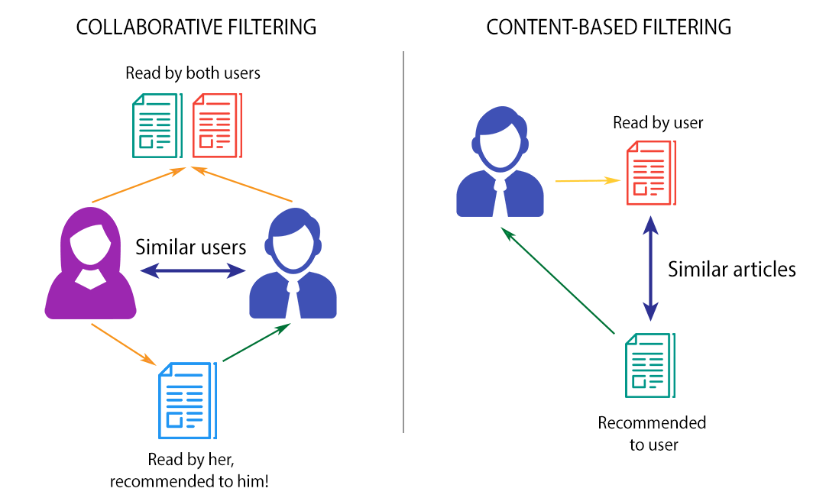

# Program design:

1. Data collection

The first step is to collect data on user behavior and product features. This data can be collected from a variety of sources, such as:

* User purchase history
* Product reviews
* Product browsing behavior
* Search queries

2. Data cleaning and preprocessing

Once the data has been collected, it needs to be cleaned and preprocessed. This involves removing any errors or inconsistencies in the data, and transforming the data into a format that can be used by the recommendation algorithm.

3. Feature engineering

Feature engineering is the process of creating new features from the existing data. This can be done by extracting meaningful patterns from the data, or by combining different features to create new ones.

4. Model selection

There are a variety of recommendation algorithms that can be used. The best algorithm for a particular project will depend on the nature of the data and the desired outcome. Some popular recommendation algorithms include:

* Collaborative filtering
* Content-based filtering
* Hybrid filtering

5. Model training

The next step is to train the recommendation algorithm on the data. This involves feeding the data into the algorithm and allowing it to learn the relationships between users and products.

6. Model evaluation

Once the model has been trained, it needs to be evaluated. This can be done by using a holdout dataset, or by using a metric such as accuracy or precision.

7. Model deployment

Once the model has been evaluated and deemed to be satisfactory, it can be deployed. This involves making the model available to users so that they can receive recommendations.

8. Monitoring and maintenance

The final step is to monitor and maintain the recommendation system. This involves monitoring the performance of the system, and making changes as needed.

# Testing:

* User-based evaluation: This involves asking users to rate the recommendations they receive. This can be done through surveys or A/B testing.
* Item-based evaluation: This involves measuring the similarity between items that have been recommended to the same user. This can be done by calculating the cosine similarity between items.
* Offline evaluation: This involves using a held-out dataset of user ratings to evaluate the accuracy of the recommendations. This can be done by calculating the mean absolute error (MAE) or the root mean squared error (RMSE).
* Online evaluation: This involves tracking the actual purchases made by users after they have been recommended items. This can be done by tracking the click-through rate (CTR) or the conversion rate.

# Conclusion:

The Amazon Recommendation System project is a great example of how data science can be used to improve the user experience of an online shopping website. By recommending products that are similar to items that a user has previously purchased or viewed, Amazon is able to increase the chances that the user will find something they are interested in. This can lead to increased sales and customer satisfaction.

There are a number of different ways that Amazon could improve its recommendation system in the future. For example, the company could use more sophisticated algorithms to take into account the user's browsing history, product reviews, and other factors. Additionally, Amazon could experiment with different ways of displaying recommendations, such as using a personalized sidebar or a "most likely to buy" section.

Overall, the Amazon Recommendation System is a valuable tool that helps Amazon to provide its customers with a more personalized shopping experience. As the company continues to collect more data and improve its algorithms, the recommendations will become even more accurate and relevant.

* Recommendation systems are a powerful tool that can be used to improve the user experience of an online shopping website.
* There are a number of different ways to build a recommendation system, each with its own advantages and disadvantages.
* Amazon uses a variety of factors to generate its recommendations, including user purchase history, product reviews, and product metadata.
* The Amazon Recommendation System is constantly being improved, and the company is always looking for new ways to make its recommendations more accurate and relevant.

# References:

* Amazon Product Recommendation System: https://medium.com/analytics-vidhya/amazon-product-recommendation-system-855c9d3df481
* Recommender System Using Amazon Reviews: https://www.kaggle.com/code/saurav9786/recommender-system-using-amazon-reviews
* Building a Recommender System for Amazon Products with Python: https://towardsdatascience.com/building-a-recommender-system-for-amazon-products-with-python-8e0010ec772c
* Amazon Recommender System: https://library.ucsd.edu/dc/object/bb8503744c/_2_1.pdf
* Amazon Recommendation System using Python: https://thecleverprogrammer.com/2021/03/23/amazon-recommendation-system-using-python/
* Recommendation System - Amazon - Application of ML: https://www.codingninjas.com/studio/library/recommendation-system-amazon-application-of-ml
* A Complete Study of Amazon's Recommendation System: https://www.argoid.ai/blog/decoding-amazons-recommendation-system

.

# Screenshot:

